**PROJECT DOCUMENTATION.**

**PRESENTED BY:**

* **Joseph Abdulazeez. M**
* **Yusuf Ibrahim Mainasara.**
* **Fahad Sani Danjuma.**

**TOPIC: TASHA’S HOME STORE AND KITCHEN APPLIANCES**

**A project on Building Next Generation Websites.**

**APTECH.**

e-project is a step-by-step learning environment that closely simulates the classroom and Lab based learning environment into actual implementation. It is a project implementation at your fingertips!! An electronic, live juncture on the machine that allows you to

* Practice step by step i.e. laddered approach.
* Build a larger and more robust application.
* Usage of certain utilities in applications designed by user.
* Single program to unified code leading to a complete application.
* Learning implementation of concepts in a phased manner.
* Enhance skills and add value.
* Work on real life challenging projects.

**Objectives of the project.**

The Objective of this project is to develop a website, “TASHA KITCHEN APPLIANCES” that provides a collection of appliances with different categories to match the fast life of our generation.

**Problem Statement.**

TASHA - *the home store* is a Branded Company famous for home kitchen appliances. It provides collection of number of appliances with different categories to match the fast life of our generation. The Tasha group of companies had made huge profit in the year 2013. In order to enhance its business, the organization wants you to develop the website.

**Requirement Specification/Solutions:**

This Web site was created based on the following requirements.

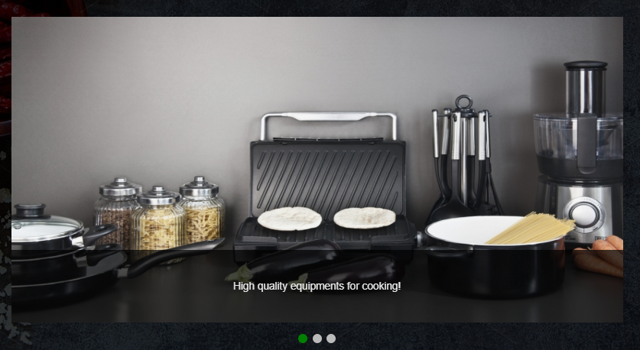

1. The Home page must include images with slide show and links for navigation.
2. Proper template must be designed for the website, few sections of the webpage can be included to show or 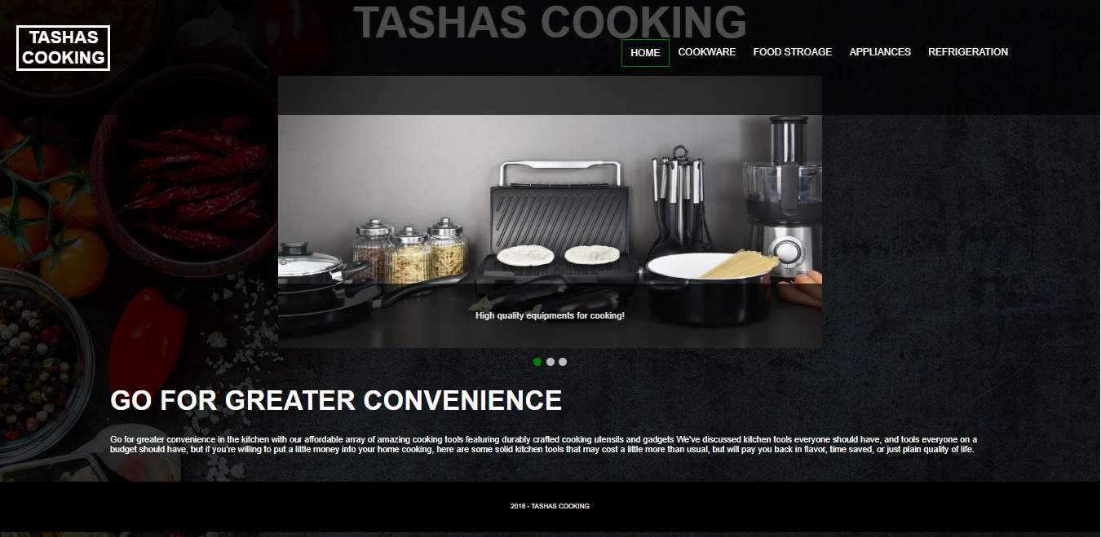advertise the upcoming products.
3. Categories like Cookware, Refrigeration, Appliances, Food Storage, Appliances and other accessories are available



1. The contents for the dropdown list are located once you hover. 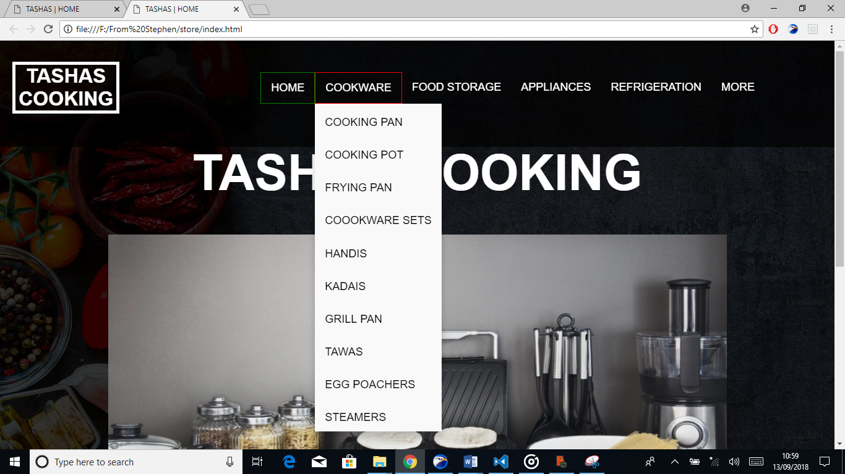
2.  The Software used in building the code from the ground up was none other than “visual studio code” and “notepad++” working side by side.
3. Support links information are located in the “MORE” navigation section.

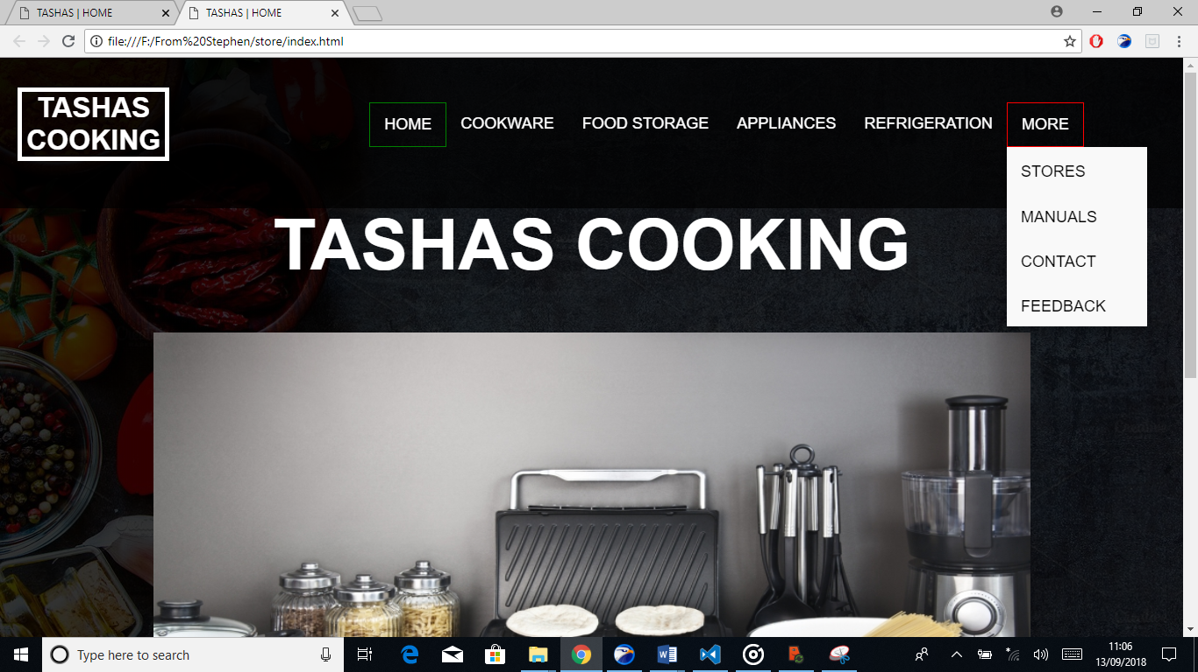

1. Store Locators: must display the address location of all the branches available.

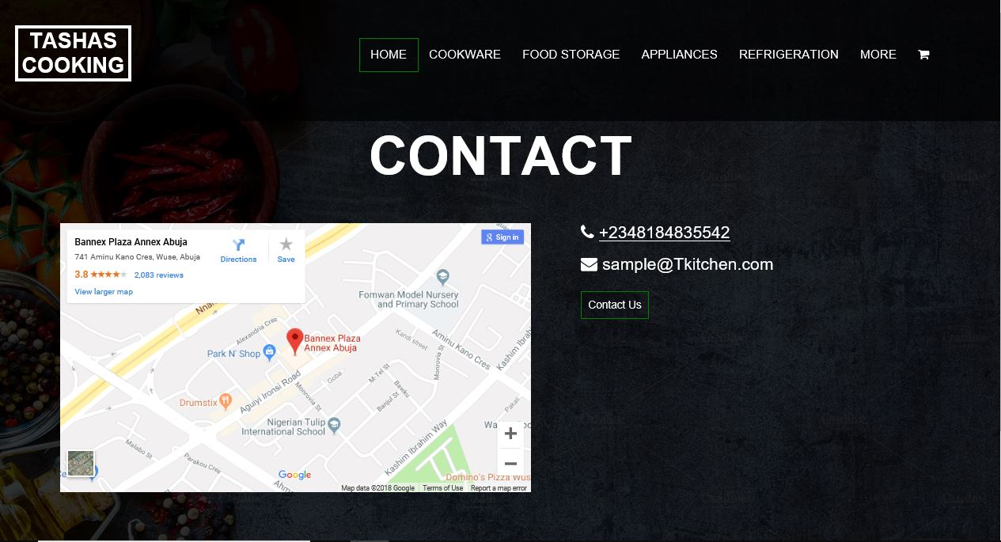

1. 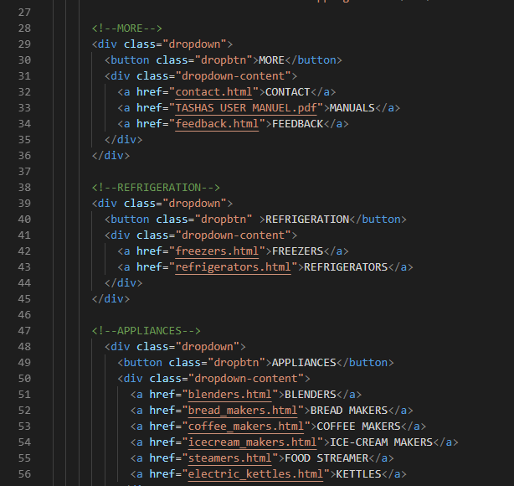The code for how the dropdown was made
2. 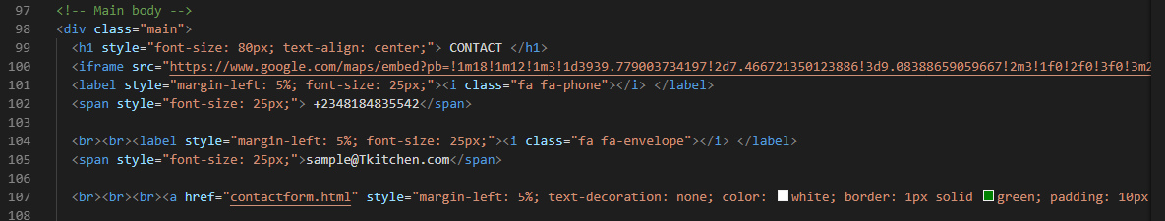The code for the contact us page is located in the “contact.html” from line 97-107
3. For further information about the code each html code is carefully detailed as a comment at the start of the code to the end